Table of Contents
TASK 1: Introduction and Project Plan 2
Purpose of the report 2
Structure of the report 2
Project Plan 2
Selected data analytics framework 3
COTS’s Coffee Shops KPIs 3
TASK 2: Data Preparation Quality issues and Remedies 3
Generic data problems 3
Specific data problems with the COTS dataset 4
TASK 3: Data Analysis and Commentary 6
Table A: Sales volume and values 6
Table B: Comparisons of Product 7
Table C: Comparison of Sales volume and values between coffee shops 8
TASK 4: Data Visualization and Commentary 9
Chart A: Comparison of sales values 9
Chart B: Comparison between coffee shops 12
Chart C: Impact of home delivery service 14
TASK 5: Conclusion and Recommendations 16
Conclusion 16
Recommendations 16
Reference 18

$$FIRST TASK: Introduction and Project Plan$$

Purpose
This study will be a critical component of COTS's three-year strategic plan because it provides knowledge-based insights to help the senior management. However, the analysis seeks to identify growth prospects, improve profitability, and optimize operations by analytical sales performance, product offering, and the influence of home delivery services. Moreover, the main purpose of the report is to address three issues and identify future plans as well as expansion of new product in the coffee shops.

Structure
The report will be categorized into five separate sections where each of will accurately identify crucial aspects of the case study. As an introduction, Task 1 will lay the basis by offering a complete evaluation of the project strategy and the selected data analytics framework that will guide the whole analytical process. On another side, to guarantee the data's dependability and accuracy for in-depth the Task 2 will study data preparation quality difficulties and their related remedies. Afterward, Task 3 will Present the results of the data analysis by using numerical data tables and insightful remarks. The task 4 will provide brief insightful interpretations of the findings as well as compelling data visualizations. In the end Task 5 will be vital to the report because it will use the study's complete results to draw strategic recommendations.

Project Plan
The project plan includes a number of essential steps to ensure the analysis is delivered effectively. It begins with data collection from the coffee shops in Blackpool, Southampton, & Portsmouth with an emphasis on maintaining data accuracy and integrity. Any issues with data quality, such as missing values, duplication, and inconsistencies, are then resolved to guarantee the correctness of the analysis. Therefore, it is important to conduct exploratory data analyzes to identify important trends, patterns, and outliers that may provide important information for future research. Sales and Volume Examination In-depth examination of deals information to distinguish coffee shops with the most prominent potential for development. Item conveyance ponders analyze the execution of different item categories to move forward to the coffee shop's benefit. Recognize undesirable items and evacuate them from the menu. Survey the effect of the dispatch benefit on the sales execution of the Blackpool store and visit other stores. Information visualizations are made to viably communicate Beds investigation comes about, make strides understanding, and help choice making. The investigate concludes with vital suggestions based on comprehensive examination for Beds and CEOs and senior administration. These experiences will enable organization to form choices and accomplish development and victory based on the three-year vital arrange (Heilig, et al., 2020).

Selected data analytics framework
This inquiries about employments a data-driven decision-making demonstrate. This show centers on utilizing information to direct commerce choices, back key procedures, and unravel basic trade challenges. Utilizing this strategy, the report can assess the execution of Bunks and cafeterias and give important data for choice making.

COTS’s Coffee Shops KPIs
The coffee shops measure execution utilizing key execution markers (KPIs) such as sales, productivity, client fulfillment and advertise share. Moved forward analytics can degree and get it these key execution markers (KPIs), Bunks can distinguish openings for development, increment item offerings, progress operational productivity and react suitably to changing showcase needs. In outline, this think about gives a basic outline of Bunks and cafeteria operations and gives vital proposals to back the improvement of a three-year vital arrange. This will make evidence-based choices and offer assistance the commerce accomplishes its objectives and develop (Carriere, et al., 2019).

$$SECOND TASK: Data Preparation Quality issues and Remedies$$

Generic data problems
Missing information implies that no esteem is recorded for a perception or condition. Carefully inspecting your dataset to identify blank cells or NULL values ​​can help find missing data.
Duplicate data: Items that appear more than once in a dataset with similar content are classified as duplicates. Comparing the lines to identify exact matches will help you find them, because you can bias your selection decisions (Hook, et al., 2021).
Inconsistent data occurs when the values ​​associated with the same attribute are presented in different ways. Examples of this include changes in date formats, units of measurement, and naming standards.
Definition: An outlier is a value that is significantly different from the rest of the data. Factual strategies ought to be utilized to distinguish potential predispositions within the comes about of the examination.
Data Mistakes: Information sets are subject to blunders due to human mistake all through the information section handle. Confirmation and communication with sources are imperative to distinguish information passage issues.
Addressing common information issues is basic to keeping up information keenness and quality. Here are arrangements for these issues:
Data imputation alludes to the method of filling in lost values in a information set. Ascription strategies can be utilized to approximate lost information values by analyzing designs within the accessible data.
Data mining includes evacuating copy information by expelling copy sections and keeping as it were one of each special record (Alipour-Vaezi, et al., 2022).
Data standardization is the method of changing over crude information into standard groups, units, or naming traditions to guarantee consistency.
Controlling for outliers: Two conceivable ways to control for exceptions in a consider are to remove them or to create changes to reduce their impacts.
Data confirmation and approval alludes to the method of guaranteeing the precision, unwavering quality and legitimacy of information. Employing a careful approval and approval prepare earlier to information examination can recognize and resolve information passage issues.

Specific data problems with the COTS dataset
Problems: The dataset has several issues that need to be resolved. First, there are places where there are many categories and months where missing data is flagged. In addition, there are many errors and typos that reduce the accuracy of the data, and the column names are not consistent. Also, it is important to correct some incorrect data entries, such as incorrect sales numbers. The date format used in "Year" No fever either. To use the dataset correctly, it is important to correct spelling errors, handle missing data correctly, correct column names, and ensure correct and consistent date formats (Rohani, et al., 2022).
Problem Solving Skills: Preparing a data set for analysis requires performing some data cleaning and normalization tasks.
- First, it is necessary to handle the missing data points by replacing them with the mean or average sales volume corresponding to the product category and location.
- Product categories and locations should be standardized to reduce confusion and misunderstandings. Inconsistencies or errors in your naming conventions should be corrected.
- In addition, data must be validated to ensure accuracy by reporting inaccuracies and checking compliance with established business rules.
- People and articles are arranged in bullet points. Accurate sales data is important, because negative values ​​may indicate errors that should be corrected with actual data.
- Also, the date format must match "YYYY-MM" to ensure correctness of the dataset. It is recommended that researchers or domain experts be included in the data validation process.
- This is because they can provide important features and identify issues or differences that may be missed using automated methods. Cite with "Miron, et al., 2020and"; It refers to a 2020 publication by Miron and colleagues (Miron, et al., 2020).

$THIRD TASK: Data Analysis and Commentary$

Table A: Sales volume and values
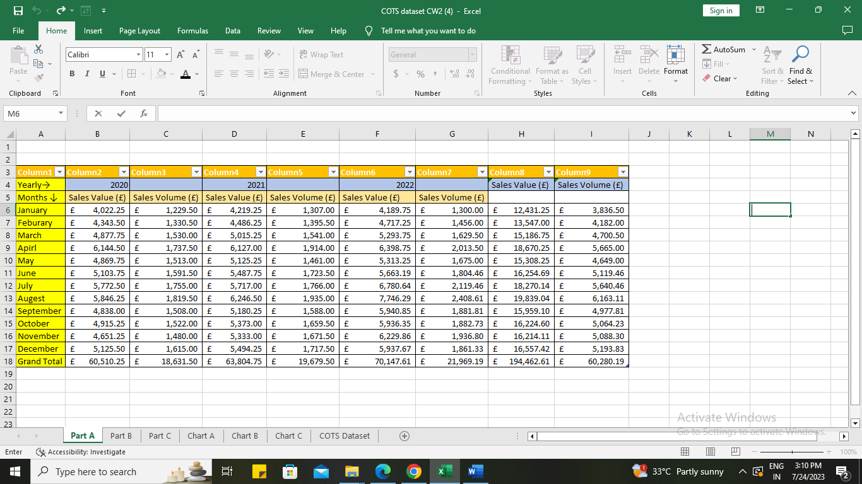
The sales volume and value information for various product categories & months for the years 2020, 2021, and 2022 are shown in the above mention table. However, the table consist of total sales performance, best and worst product performance categories, seasonal patterns, and assessing annual growth are the main goals of the data analysis. Moreover, significant insights are revealed by the examination of the company's three-year performance. The total sales value increased steadily from £60,510.25 in 2020 to £63,804.75 in 2021 and then to £70,147.61 in 2022, suggesting overall success and growth. Likewise, the overall volume of sales increased steadily, rising to 18,631.50 units in 2020, 19,679.50 units in 2021, and 21,969.19 units in 2022 (Sazvar, et al., 2022).
The best-performing month was always December, while January and September had the worst results. Moreover, examining seasonal trends can aid in the successful planning of inventory and marketing tactics. Understanding the company's trajectory and the effectiveness of its strategies will be possible with the aid of the year-over-year growth rate calculation, which will help businesses succeed by adjusting to changing market conditions. Enhancing accessibility for stakeholders and decision-makers by presenting tables in a professional manner and emphasizing important data points.

Table B: Comparisons of Product
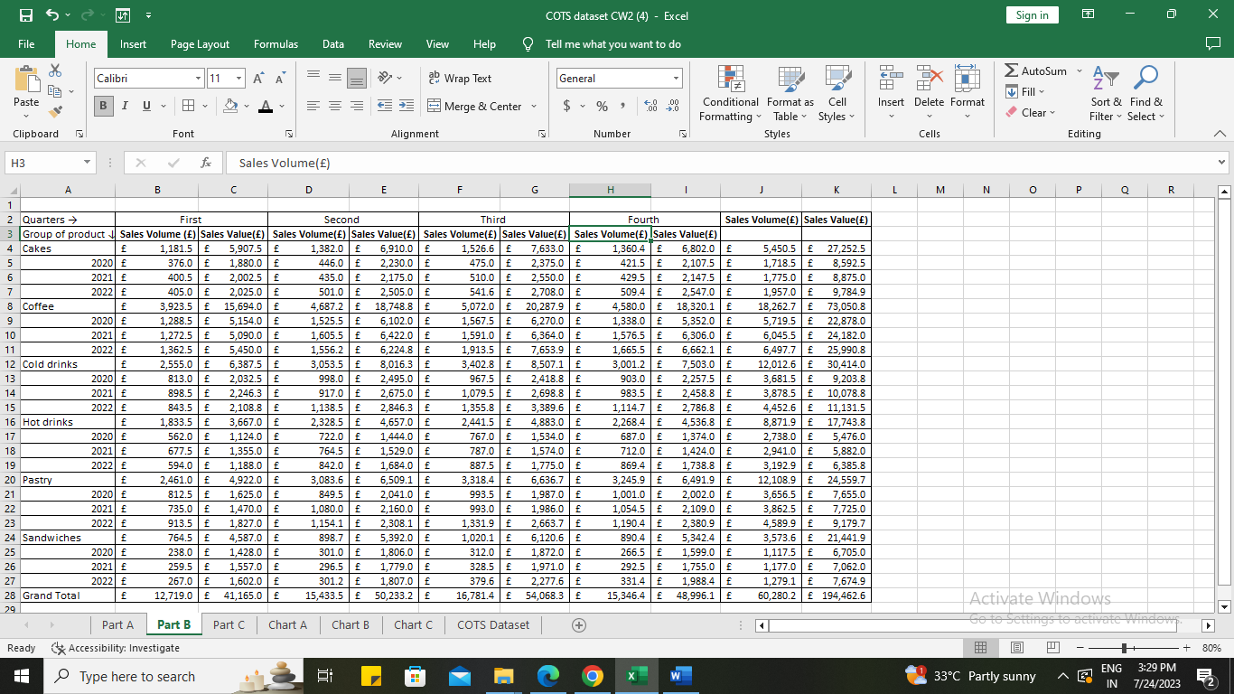
In this table, sales volume and value information for the five product categories of cakes, coffee, cold drinks, hot drinks, and pastries are shown for the three years of 2020, 2021, and 2022. Each product category's information is arranged according to quarters (First, Second, Third, and Fourth). The "Grand Total" row at the bottom totals up the overall volume and dollar amount of sales for all product categories and fiscal quarters (Dodman, et al., 2019).
Key observations
Top performing product categories: Over the period of three years, coffee has consistently demonstrated the highest sales volume and value, followed by cold drinks and pastries. Compared to other categories, cakes have the least amount and value of sales.
Seasonal trends: In most categories, sales volume and value generally rise from the first to the third quarter and then somewhat decline in the fourth, possibly reflecting seasonal demand trends.
Overall growth: Both sales volume & sales value have increased throughout the years in a favorable trend, showing overall business growth.
Variability: Compared to other categories, Pastry and Coffee show greater variations in sales volume and sales value, indicating greater fluctuation in their sales performance.
Yearly performance: A potential growth has been noted in the sales volume and values (YILMAZ, et al., 2022).

Table C: Comparison of Sales volume and values between coffee shops
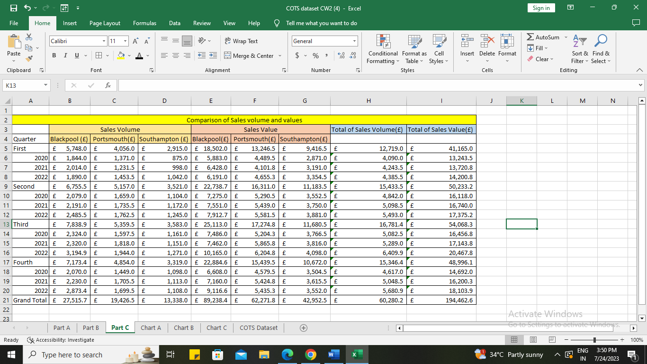
A comparison of sales volume and values for three distinct locations (Blackpool, Portsmouth, and Southampton) across four quarters from 2020 to 2022 is shown in the table, along with each location's respective total volume and total value of sales in pounds (£).
Summary of data calculations
Top-Performing Product Categories: Blackpool regularly comes out as the best-performing location in terms of sales volume & value, across all quarters and years (Barbu, et al., 2022).
Bottom performing product categories: Southampton regularly has the lowest sales volume and value among the three sites in terms of product categories.
Ranges: The differences in sales volume and value across the quarters and years point to probable seasonal trends or shifts in the performance of the company.
Averages: To comprehend their regular performance levels, the average sales volume and value for each site may be computed.
Standard deviations: The unpredictability or volatility of sales trends for each site during the specified period may be determined by looking at the standard deviations of sales volume and value.
Key observations
- Blackpool is an important market for the business since it routinely leads in both sales volume and value.
- The fact that Southampton continuously performs below average in terms of sales volume and value points to prospective areas for development or ways to increase sales there.
- Sales volume and value have generally increased throughout the years across all sites, showing overall business growth (Cen, 2022).
- For all locations, the fourth quarter of 2022 looks to have the largest sales volume and value, which may be explained by seasonal factors or particular marketing initiatives around that time.

$$FOURTH TASK: Data Visualization and Commentary$$

Chart A: Comparison of sales values
The sales figures for three locations; Blackpool, Portsmouth, and Southampton as well as their cumulative values over a three-year period (2020–2022) are shown in the table. The following are the main findings:
- From 2020 to 2022, there was an upward tendency in the sales values for all locations.
- With a total of £89,238.36 in sales over the course of the three years, Blackpool continuously had the greatest sales.
- With combined sales of £62,271.75 and £42,952.50, Portsmouth and Southampton came in second and third, respectively (Fernandes, 2019).
- 2021 had the greatest value (£63,804.75) of all the years' combined sales.
- With varying patterns, the monthly sales values fluctuated between places and years.
Bart chart

- The three-year total sales for each site are shown graphically in the bar chart.
- The bar is always set the highest in Blackpool, with Southampton and Portsmouth following.
- The bars display an upward trend over time, indicating an increase in sales.
Stacked bar chart

- With distinct colors designating each location, the stacked bar chart shows the monthly sales for each location over the course of a year.
- Consistently, Blackpool gets the most share, then Southampton, Portsmouth, and Blackpool.
- Even if there are peaks and valleys, each location's general trend is still upward, showing growth in monthly sales (Siew, et al., 2022).
Trend Chart

- The trend chart shows the general sales pattern for each area between 2020 and 2022.
- Across the board, there is an increasing trend, pointing to sustained sales growth over the past three years.
- Portsmouth and Southampton's and Blackpool's trends are the steepest, demonstrating Blackpool's superior performance in terms of sales growth.

Chart B: Comparison between coffee shops
Bart chart

- The bar graph shows the sales information for several items in Blackpool, Southampton, and Portsmouth.
- Blackpool had the largest sales of "cakes" ($2,522.99), followed by Southampton ($1,192.00) and Portsmouth ($1,735.50).
- Blackpool (£8,321.19), Portsmouth (£5,806.50), and Southampton (£4,135.00) had the biggest "coffee" sales.
- Blackpool (£5,489.09), Portsmouth (£3,862.50), and Southampton (£2,661.00) had the biggest "cold drinks" sales (Tazzit, et al., 2021).
- Blackpool (£4,094.91), Portsmouth (£2,931.00), and Southampton (£1,846.00) had the greatest "hot drinks" sales.
- Blackpool (£5,455.86), Portsmouth (£3,924.00), and Southampton (£2,729.00) had the biggest "pastry" sales.
- The biggest "sandwiches" sales were recorded in Blackpool (1,631.64 pounds), followed by Portsmouth (1,167.00 pounds), and Southampton (775.00 pounds).
- Blackpool, Portsmouth, and Southampton each had a total of 27,515.69, 19,426.50, and 13,338.00 pounds in sales.
- £60,280.19 is the total amount of sales across all cities (Luthfi, et al., 2019).
Stacked bar chart

- In all cities, coffee makes up the largest portion of overall sales.
- The greatest overall sales are in Blackpool, with coffee playing a significant role.
- Sandwiches are the least popular product in Southampton, which has the lowest overall sales.
Trend Chart

- Overall, Blackpool and Portsmouth have bigger sales than Southampton.
- The sales of every product are rising.
- Sales rise for coffee and pastries has been particularly rapid over the observational period.
- The most sluggish sales growth is seen in sandwiches.

Chart C: Impact of home delivery service
Bar chart: For each quarter from 2020 to 2022, the bar graph shows the dollar amount of sales for various items in three cities (Blackpool, Portsmouth, and Southampton).

- All items sold over the examined time have consistently had the top sales in Blackpool.
- Every quarter, Southampton has the lowest sales of any product.
- For all locations and items, sales indicate an upward tendency over time.
- With Blackpool playing a key role, the fourth quarter of 2022 witnessed the greatest total sales (Reeves, et al., 2020).
Stacked chart: The stacking graph from 2020 to 2022 shows the quarterly sales value of each product in three cities.

- In all cities and neighbourhoods, coffee and pastries are consistently the best-selling goods.
- Every quarter, Blackpool has the greatest overall sales, followed by Southampton and Portsmouth.
- In each city, sales of sandwiches and cold beverages make up a significantly lower portion of the overall revenue.
Trend chart: The sales trends of several items in three cities from 2020 to 2022 are shown on the trend chart (Cao, et al., 2021).

- Over the examined time, sales of all items have usually increased.
- Sales increase in Blackpool, Portsmouth, and Southampton is consistently the sharpest.
- Coffee and pastries have greater sales growth rates than other items.
- From the three cities, sales in Southampton are growing most gradually (Ortiz, 2020).

$$FIFTH TASK: Conclusion and Recommendations$$

Conclusion
Throughout, the three years from 2020 to 2022, sales volume and value at COTS's coffee shops have grown steadily. Sales in Blackpool typically outpaced those in Southampton and Portsmouth, demonstrating the importance of the area to the business. The best-performing month was found to be December, and the first to third quarters typically had larger sales than the fourth. Seasonal tendencies were also found. The best-selling product categories overall were pastries, coffee, and cold drinks, with cakes having the lowest sales. Additionally, the data showed that the home delivery service increased sales, especially in Blackpool.

Recommendations
Product optimization: COTS should priorities streamlining its product lineup in accordance with the top-performing segments. Higher profits may be obtained by investing in coffee, cold drinks, & pastries, while underperforming selections such cakes should be examined for possible revisions or omission from the menu.
Improve sales in Southampton: COTS should do market research to identify client preferences and adjust its offers in order to solve the weaker sales performance in Southampton. Customer attraction and retention in this sector can also be aided by the introduction of special incentives and loyalty programs.
Customer experience: Customer experience enhancement need to be a top objective for COTS. Higher client retention and satisfaction can result from ensuring constant service quality, personalized interactions, and a smooth home delivery service.
Sustainability Initiatives: Given the market's increased emphasis on sustainability, COTS may want to establish eco-friendly procedures and provide sustainable goods. Customers who care about the environment may find this appealing, and the brand's reputation may improve.
Employee training and development: The whole customer experience may be greatly impacted by a motivated and well-trained workforce. To achieve great customer service and product expertise, COTS should fund employee education and growth programs.

Reference
Heilig, L., Stahlbock, R. and Voß, S., 2020. From digitalization to data-driven decision making in container terminals. Handbook of terminal planning, pp.125-154.
Carriere, T. and Kariniotakis, G., 2019. An integrated approach for value-oriented energy forecasting and data-driven decision-making application to renewable energy trading. IEEE transactions on smart grid, 10(6), pp.6933-6944.
Hook, J., El-Sedky, S., De Silva, V. and Kondoz, A., 2021. Learning data-driven decision-making policies in multi-agent environments for autonomous systems. Cognitive Systems Research, 65, pp.40-49.
Alipour-Vaezi, M., Tavakkoli-Moghadaam, R. and Samieinasab, M., 2022. Scheduling the COVID-19 vaccine distribution based on data-driven decision-making methods. Journal of Industrial Engineering and Management Studies, 8(2), pp.196-206.
Rohani, V.A., Peerally, J.A., Moghavvemi, S., Guerreiro, F. and Pinho, T., 2022. Illustrating scholar–practitioner collaboration for data-driven decision-making in the optimization of logistics facility location and implications for increasing the adoption of AR and VR practices. The TQM Journal, 34(2), pp.280-302.
Miron, M., Tolan, S., Gómez, E. and Castillo, C., 2020. Addressing multiple metrics of group fairness in data-driven decision making. arXiv preprint arXiv:2003.04794.
Sazvar, Z., Tavakoli, M., Ghanavati-Nejad, M. and Nayeri, S., 2022. Sustainable-resilient supplier evaluation for high-consumption drugs during COVID-19 pandemic using a data-driven decision-making approach. Scientia iranica.
Dodman, S.L., DeMulder, E.K., View, J.L., Swalwell, K., Stribling, S., Ra, S. and Dallman, L., 2019. Equity audits as a tool of critical data-driven decision making: Preparing teachers to see beyond achievement gaps and bubbles. Action in Teacher Education, 41(1), pp.4-22.
YILMAZ, E. and JAFAROVA, G., 2022. Development of Data Driven Decision Making Scale: A Validity and Reliability Study. Research on Education and Psychology, 6(Special Issue), pp.69-91.
Barbu, S.J., McDonald, K., Brazil-Cruz, L., Sullivan, L. and Bisson, L.F., 2022. Data-Driven Decision-Making. Uprooting Bias in the Academy: Lessons from the Field, pp.47-59.
Cen, S.H., 2022, June. The Right to be an Exception in Data-Driven Decision-Making. In Ethical Issues in Computing & AI Conference (Vol. 3).
Fernandes, V., 2019. Investigating the role of data-driven decision-making within school improvement processes. In Evidence-based initiatives for organizational change and development (pp. 201-219). IGI Global.
Siew, L.W., Hoe, L.W., Bakar, M.A. and Fun, L.P., 2022. Data driven decision analysis on the performance of electronic companies with TOPSIS model. Journal of Advances in Information Technology Vol, 13(1), pp.61-66.
Tazzit, S., Ibne Hossain, N.U., Nur, F., Elakramine, F., Jaradat, R. and El Amrani, S., 2021. Selecting a Biomass Pelleting Processing Depot Using a Data Driven Decision-Making Approach. Systems, 9(2), p.32.
Luthfi, A. and Janssen, M., 2019. Open data for evidence-based decision-making: Data-driven government resulting in uncertainty and polarization. International Journal on Advanced Science, Engineering and Information Technology, 9(3), pp.1071-1078.
Reeves, T.D., Onder, Y. and Abdi, B., 2020. Validation of the Data-Driven Decision-Making Efficacy and Anxiety Inventory (3D-MEA) with US pre-service teachers. Mid-Western Educational Researcher, 32(4), pp.286-303.
Ortiz, V.B., 2020. Data driven decision making through bio-inspired principles.
Cao, J. and Gao, R., 2021. Contextual decision-making under parametric uncertainty and data-driven optimistic optimization. Available at Optimization Online.

